Sherbrooke Scout Campsite
Central Notts District
Main Centre Fire Zones and Locations
Fire Zones 1 – 4
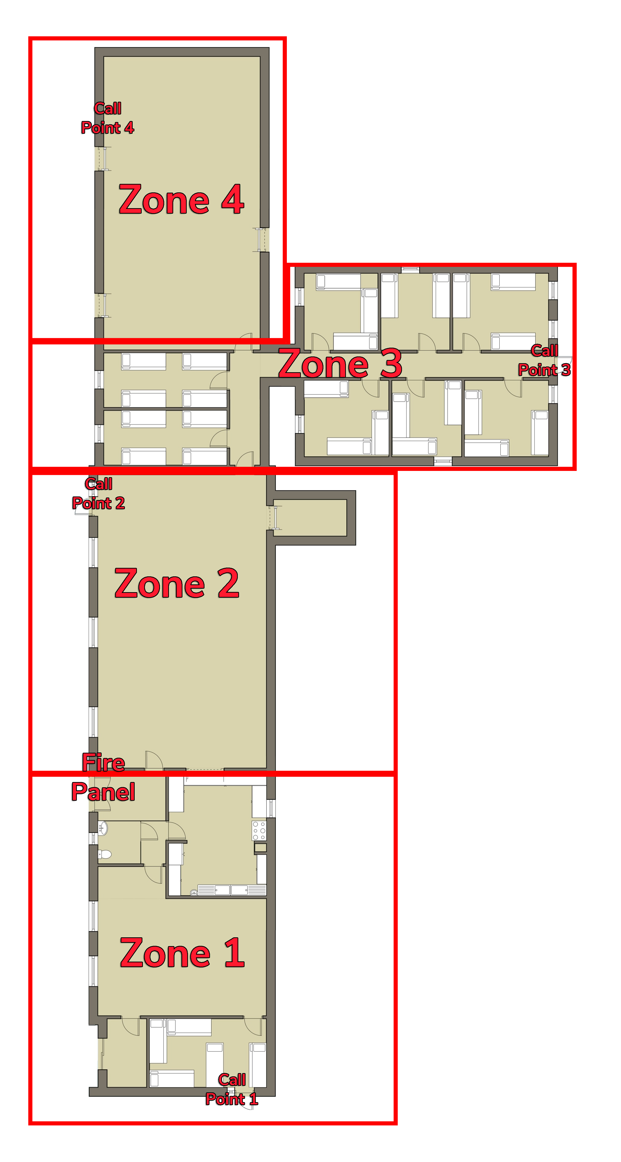Call Points 1 – 4

Fire Alarm Panel
The Fire Alarm Panel is located in the Entrance Hall to the Main Centre, it will indicate where the potential fire could be located, it will indicate if it is a Fire Sensor or a Call Point, See below for explanations for both.
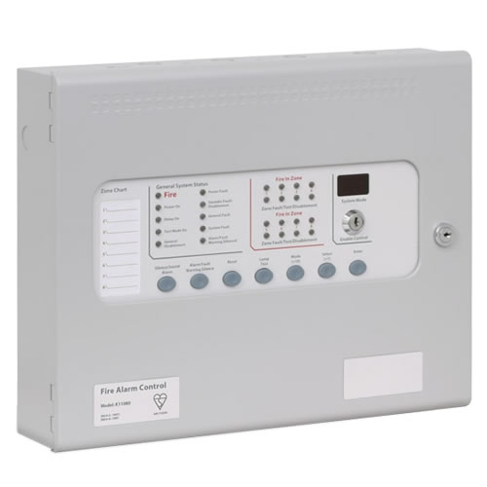
What is a Fire Zone
A fire zone is an area where sensors and Call Points are located, which are then indicated by the Fire Panel where a Possible fire is located.
What is a Call Point
A call point is a Red Box located on the wall, which if someone finds a fire can be set off manually, setting the Fire Alarm off indicating to everyone in the building that a fire has been found, where it could be located and then everyone can follow the fire procedures listed.
If a Call Point has been set off, the Light on the box will Flash Red.
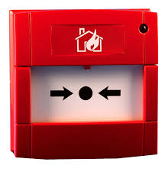
What is an Automatic Fire Sensor
An Automatic Fire Sensor is located on the ceiling across the building, if these pick up Heat, Smoke, or Fire, the Sensor will set the Alarm off, and will then indicate what Fire Zone has been set off.
If a Sensor has been set off a Red LED will Flash on the light, Or a Red LED will flash on a panel on the wall if it has been set off in a void.
